**Newton’s Laws Problems**  Name <Dessa Shapiro>

| Formula | Variables |
| --- | --- |
|  | S = Speed (slightly different than velocity…)  D = Distance  T = Time |
|  | V = Velocity |
|  | a = acceleration  V(final) = Final Velocity  V(initial) = Initial Velocity |
|  | f = force  m = mass  a = acceleration |
|  | w = weight  g = the force of gravity  m = mass |

Force of Gravity on Earth = 9.8 Newtons

Force of Gravity on the Moon = 1.6 Newtons

Force of Gravity on Jupiter = 24.8 Newtons

1. **Inertia. Newton’s First Law of Motion.**

1a. What is the tendency of an object at rest when no forces act on it? < The object's tendency is to stay at rest.

2a. What is the tendency of an object in motion when no forces act on it?<The object's tendency is to stay in motion.

**Speed, velocity and acceleration. Newton’s Second Law of Motion.**

1b. Calculate the speed of a bowling ball that moves 8 meters in 4 seconds.< S= DT

S= (8m)(4s) S= 32 m/s

2b. Calculate your average speed if you run 50 meters in 10 seconds. What other variable do you need to add to this number so that it will represent your velocity? < S=DT S=(50m)(10s) S=500m/s> < you would need the change of position instead of just distance and the change of time>

3b. What is the acceleration of an object that moves from 0 to 10 m/s in one second?< a= 10-0/1 a= 10 m/s^2>

4b. Why does the unit of time enter twice in the unit of acceleration?< It enters twice because there are two units of velocity that include time as well as the time itself >

5b. According to Newton’s second law of motion, F=ma. A train has a mass of 10,000 kg. What is the acceleration produced by a force of 5000 N?< A=f/m A=5000/10000 A=0.5>

**Mass vs Weight:**

1c. What is the standard unit of measurement for mass? < Kilograms everywhere else and pounds in the US>

2c. What is the standard unit of measurement for weight? < Newtons are the standard >

3c. Are mass and weight directly proportional to each other, or inversely proportional to each other? <Mass and weight are directly proportional to each other>

4c. Does a 2 kilograms bunch of bananas have twice as much inertia as a 1 kilogram bunch of bananas? Twice as much mass? Twice as much volume? Twice as much weight, when weighted in the same location? < yes it has twice the inertia, Yes, No the volume will be different, yes.>

5c. A 1-kg bag of nails weighs 9.8 Newtons at the Earth’s surface. Away from the Earth, where the force of gravity is less, will the bag of nails weigh less, the same or more? < The bag will weigh less than it did on earth>

6c. If a woman has a mass of 50 kg, calculate her weight in Newtons. < w=(9.8)(50kg) w= 490 Newtons>

7c. Calculate in Newtons the weight of a 2000 kg elephant. < w=(9.8)(2000kg) w=19600 Newtons>

8c. An apple weighs about 1 N. What is its mass in kilograms? < w=gm m=w/g m= 1N/9.8

m= 0.10204081632kg m= 102.040816320000005 g>

9c. A man finds that he weighs 700 N. Calculate his mass. < m=w/g m= 700N/9.8 m= 71.4285714286 kg>

10c. Calculate your own mass in kilograms and your own weight in Newtons. < my mass: prob about 120lbs = 54.4311 kg w=gm w=(9.8)(54.4311) w=533.42478 N

11c. The gravitational force on Jupiter is higher than on Earth. Would a car weigh less, the same or more on Jupiter than on Earth? Would the mass of the car on Jupiter be lower, the same, or higher than on Earth? < A car would weigh more on jupiter. The mass would stay to same as on earth and everywhere else.>

12c. The gravitational force on the Moon is only 1/6 that on Earth. What is the weight of a 10 kg object on the Earth and on the Moon? What is the mass of the object on the Earth and the Moon? <Mass on earth 10kg, Mass on moon 10kg. w=gm Earth w=98N Moon w=(9.8/6)(10kg) w= 16.333333 N >

**Newton’s Third Law of Motion:**

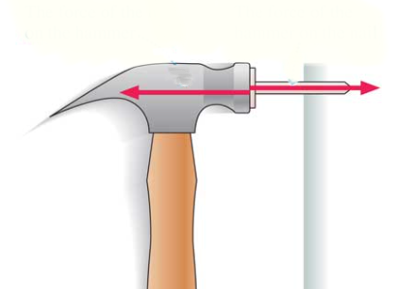

1d. When a hammer exerts a force on a nail, how does this amount of force compare with that exerted by a nail on the hammer?< The amount of force will be the same and will push back on the hammer.>

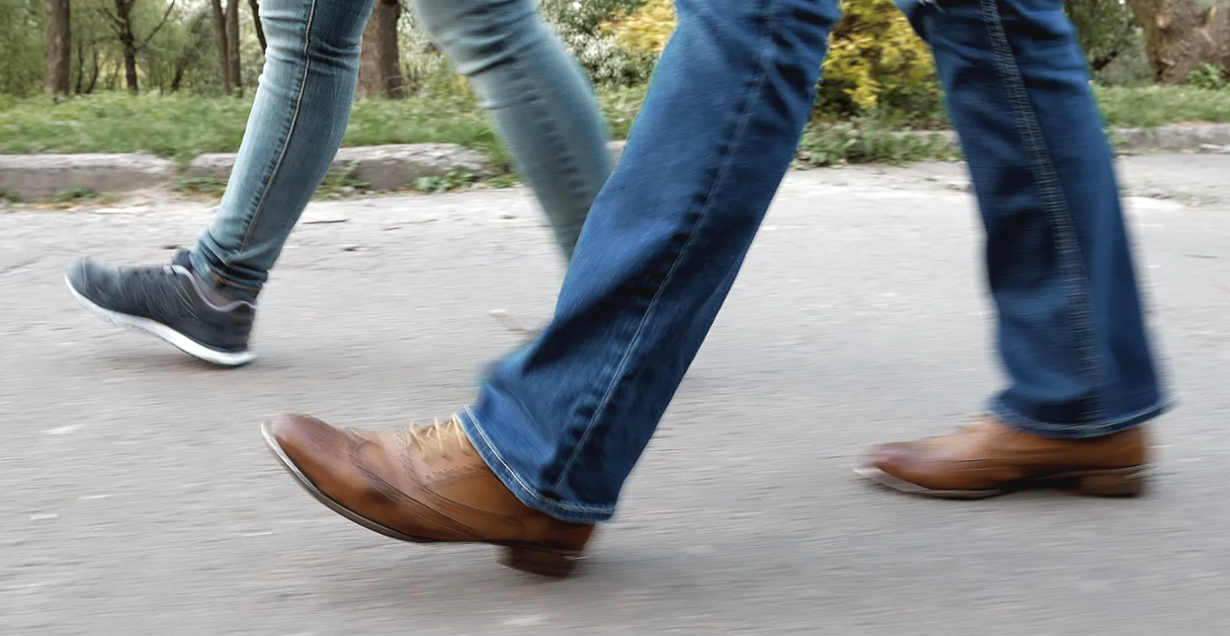

2d. When you walk on a floor, what pushes you along?<while walking you are pushing backward with your feet so the ground responds by pushing you forward.>



3d. Consider hitting a baseball with a bat. If we call the force the bat exerts on the ball the action force, identify the reaction force.< The reaction force would be the ball traveling away from the bat.>